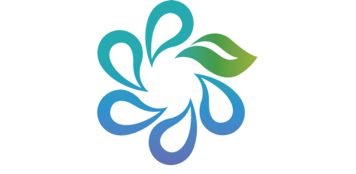

Program of Spiritual Formation and
Training in the Art of Spiritual Direction

Directed Retreat Intern Application
August 25 – September 1, 2019

We welcome you to this practicum application process.
Once your application has been received you will be contacted for an interview.

Name: ___________________________________________________ Date: ___________________

Address: ___________________________________________________________________________

Home Phone: ____________________________ Cell Phone: _________________________________

Email: _____________________________________________________________________________

Spiritual direction training program: ______________________ Date of graduation: ______________

Ongoing spiritual director practice since: ______________________ Number of directees: _________

Location and dates of previous directed retreats attended: __________________________________

__________________________________________________________________________________

How frequently do you meet with your spiritual director? ___________________________________

How frequently do you meet for professional supervision? ___________________________________

What are your hopes and desires for this retreat? __________________________________________
___________________________________________________________________________________

Include any additional information that you would like the retreat facilitator to know about you:

__________________________________________________________________________________

Emergency Contact:
Name: ____________________________________________ Relationship: ____________________

Home Phone: ____________________________ Cell Phone: _________________________________

Deposit Acknowledgement: Please note that a non-refundable deposit is due in the amount of $100.00. This deposit begins your application process and upon approval will be deducted from your practicum balance.
Balance Acknowledgement: In addition to the deposit, you are agreeing that you will pay your balance in full by August 1, 2019. Yes, I agree to these terms: Yes ⎕

Complete and mail your registration form to: The Spirituality Network, Inc.
Attn: Debbie Brenneman 444 East Broad Street Columbus, Ohio 43215

